NEUROSCIENCE SEMINAR

SPRING, 2025

Hibbard 223, 12:00 noon to 1 pm

Kurt Frazer, PhD 2/28/25

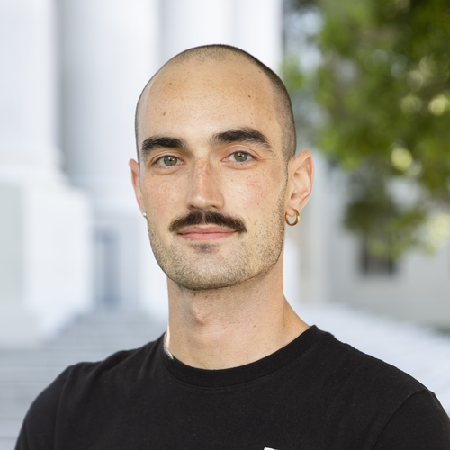

Department of Psychology, University of Minnesota

“Heterogeneous dopamine circuits for learning and motivation”

https://cla.umn.edu/about/directory/profile/kfraser

Sara Jo Nixon, PhD 4/11/25

Department of Psychiatry, University of Florida

https://psychiatry.ufl.edu/profile/nixon-sara/

Sponsored by the Wisconsin Addiction Research Laboratory

https://wiaddictionresearc.wixsite.com/wiaddictionresearch